CALL FOR APPLICATIONS - RESIDENCY

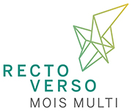

RECTO-VERSO PRESENTS ITS 2022-2023 CALL FOR PROPOSALS!

Recto-Verso Productions is the forum of expression for the transformations that stir contemporary artistic practices, by encouraging innovation and risk-taking. It supports the research, creation and distribution of multidisciplinary arts. Proactive and committed to the artists and to the community of Quebec City, Recto-Verso Productions works within a national and international network.
To learn more about our activities - Residencies - Productions - Distribution - Mois Multi Festival and other on-site activities: https://mmrectoverso.org/ (in French)
RESIDENCY - EXPERIMENTATION / CREATION

Designed with an experimental lab work in mind, this program allows for the development of projects that require intensive work in highly custom locations, using specialized equipment. In this respect, the Studio d'Essai is particularly well suited to research and experimentation. The residency program offers multidisciplinary creators an exceptional and unique creative setting in Quebec City, that allows the emergence of new artworks, the exploration of their potential in front of an audience, and the opportunity to share them with the artistic community.

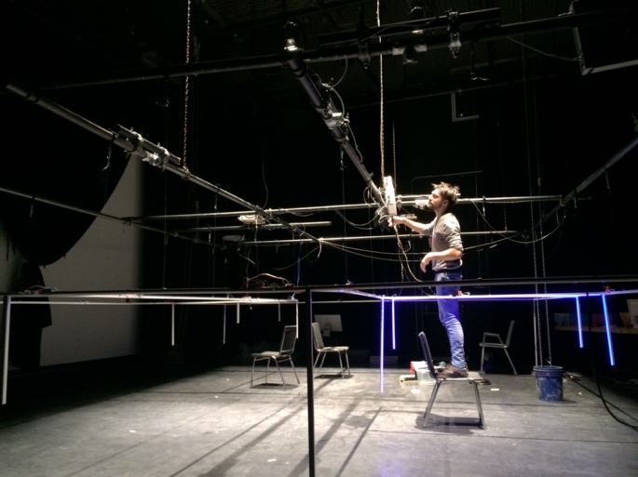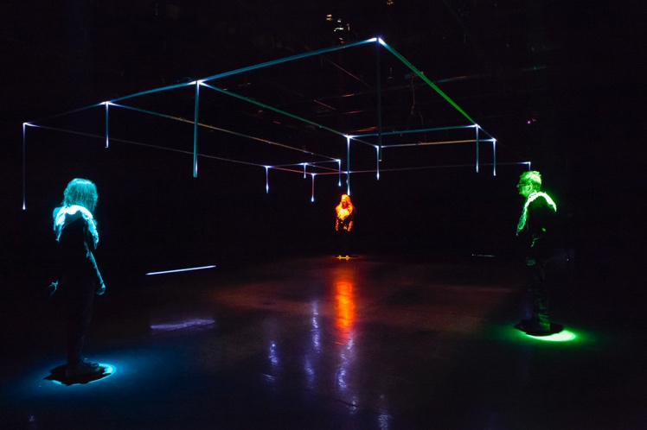Line Nault – Là (Photo credit : Stéphane Caron)

The Studio d'Essai is an open "black box"-space whose configuration is flexible and can be customized to any project. With a capacity of 150 seats and a floor area of 145 m2, the Studio d'Essai features sound, lighting and video projection systems, stage maskings, removable bleachers, an independent control room, dressing rooms and an experienced technical team! The Studio d'Essai disposes of a trampoline-grid that facilitates and accelerates the set-up of scenic, installation-type and immersive devices. Artists hosted by Recto-Verso benefit from the exceptional environment of the Méduse cooperative, which consists of 10 production and distribution organizations.
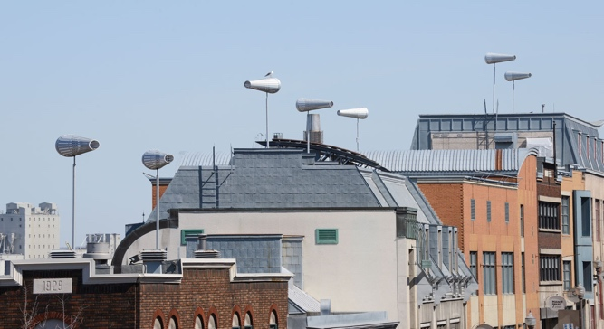
What support we offer
● A 15-day residency at Recto-Verso including: use of the Studio d’Essai, specialized equipment and technologies, advance set-up according to the project’s technical specs, so that the artist can focus on the project once on site ($8,000 value);
● Technical, artistic and logistical team support;
● Assistance with production costs - $500 fixed amount;
● Assistance with transportation and living expenses - up to $1,000;
● Assistance with accommodation expenses - up to $2,000;
● Professional network introductions - according to needs and interests;
● Organization of an end-of-residency event, such as a conference, workshop or public presentation, depending on the status of the project;
● Access upon request (member rates) to technical studios (wood, metal, image work...) in collaboration with other artist centers of the cooperative.

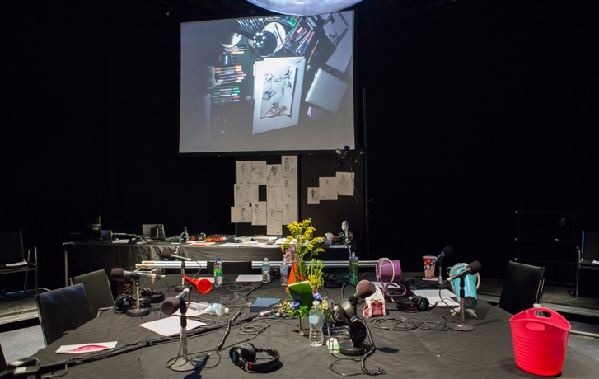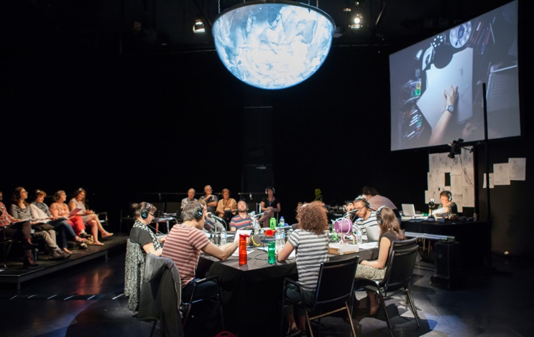Daniel Danis – Séjour (Photo credit: Marion Gotti)

HOW TO SUBMIT AN APPLICATION
Application deadline  Friday, November 5th, 2021 | Results announcement  December 2021 |  | Residency periods:  September 2022 to September 2023

Multidisciplinary artists are the targeted artists eligible to apply.
Multidisciplinary arts, new and/or hybrid artistic practices include:
● Performative practices leading to multidisciplinary proposals: scenic arts, live arts, in situ practices, from staging to music, dance, sound art, literature: storytelling, fiction, literary texts, poetry, slam, etc.
● Installation practices including: visual, media, digital, film and video arts leading to immersive type works, kinetic sculptures, interactive experiences, participatory works and soundscapes.
What to include in the application:
● A letter of interest
● A description of the project (maximum 2 pages)
● The artist's biography and resume
● Link(s) to the artist's work

Applications are evaluated according to the following criteria:
- Artistically rich and well developed;
- Stands out in terms of conceptual and/or technological innovation;
- Constitutes an expression of multidisciplinaritý and new artistic forms.
APPLICATION SUBMISSION - PLEASE COMPLETE THE FORM AND ATTACH IT TO YOUR FILE. SEND IT BEFORE NOVEMBER 5th 2021 TO THE FOLLOWING ADDRESS: PROJET@MMRECTOVERSO.ORG
All applicants will receive a response, regardless of the outcome of their application.
For any additional information, please contact:
Mélanie Bédard
Executive Director and
Program Manager
Recto-Verso Productions
melanie.bedard@mmrectoverso.org

