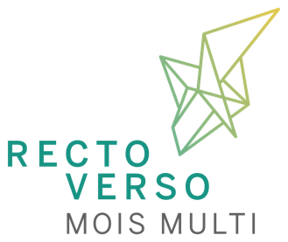
Form – Call for proposals / Residency 2022-2023

1. Information about the artist(s)
Name of the artist(s) or name of the organization |  |  |  | Represented by
Adress |  |  |  |  |  | City
Province/State/Country | ZIP CODE |  | Phone number |  | E-mail
Website |  | Links to download your virtual files (please, no transfer with a expiration date)

2. Renseignements sur le projet
Name of the project

Short description (150 words maximum)

3. My art practice and my project enter the following fields of work:

Scenic arts Performance
Performing arts Show
Work in situ Mediation with the public
Installation Immersive or participative work
Kinetic or robotic sculpture Visual arts and work of arts
Images, photos, videos or cinema Intimate experience
Movement, corporality, dance Collective experience
Theatre Electronic arts
Media arts Virtual reality or augmented reality

Others (Name what describes best your project:

4. Documents to be attached
Check P
Intention letter (demonstrating the needs of the project that can be met by us, interest in Recto-Verso Productions)
Description of the project of 2 pages (maximum) including a paragraph on your process, your artistic approach, and the multidisciplinary practice in general.
CV and biography of the submitting artist (and members of the team or collective if applicable)
Visual file of the project (if available) and previous projects (10 minutes maximum if video)
Technical specifications, floor plan, sketch or other document giving an idea of the project's location in the space and specific needs (if available)

5. Sending the form

I accept the terms and conditions of the call for projects and agree to abide by the decision of the selection committee. I certify that the information provided in support of this application is accurate and complete.

Send this form and the required documents to: projet@mmrectoverso.org
For large files, please use a storage site (Dropbox, Google Drive, etc.)

Additional information: melanie.bedard@mmrectoverso.org or 418-524-7553 ext. 1

